INFOSYS SPRINGBOARD VIRTUAL INTERNSHIP 6.0
( DATA VISUALIZATION )

Project Title:
Infosys_HotelRevai AI Driven Revenue Analysis for Hotels

Name of the Intern :
CHELIKANI HARSHAL

Milestone 4 :
Visualisation
Story Telling

TABLE OF CONTENTS

- Abstract
- Introduction
- Problem Statement
- Objectives
- Dataset Overview
- Data Preprocessing
- Data Modeling
- DAX Metrics
- Dashboard Overview
- Business Impact
- Conclusion
- Future Scope
- References

1. ABSTRACT
HotelRevAI is an AI-driven revenue analysis system designed specifically for the hospitality industry. This project utilizes a real-world hotel booking dataset containing 1,17,430 records to uncover actionable business insights through systematic data preprocessing, DAX metric modeling, and five fully interactive Power BI dashboards. The system analyzes key performance indicators including total revenue, average daily rate, occupancy percentage, cancellation rate, and RevPAR across City and Resort hotel types. By transforming raw transactional booking data into structured business intelligence, HotelRevAI empowers hotel General Managers and Revenue Managers to make data-driven decisions that optimize revenue, reduce cancellation losses, and improve operational efficiency — replacing traditional static Excel-based reporting with a single, filterable, real-time analytical platform.

2. INTRODUCTION
The hotel industry operates in a highly dynamic and competitive environment where revenue management and customer behavior analysis play a critical role in determining profitability. Traditional approaches to hotel data analysis rely heavily on static spreadsheet reports that require significant manual effort to prepare and offer limited interactivity or real-time filtering capability.
HotelRevAI addresses this gap by building an end-to-end analytical pipeline — from raw data ingestion and cleaning through KPI modeling to fully interactive dashboard visualization. Using Microsoft Power BI Desktop, Power Query Editor, DAX (Data Analysis Expressions), and M Language, this project translates complex booking-level transactional data into five purpose-built interactive dashboards covering Revenue & Booking Performance, Occupancy & Revenue Analysis, Guest Analysis & Segmentation, Cancellation & Forecasting Trends, and Revenue Strategy & Pricing Insights.
The project followed a structured milestone-based workflow under the Infosys Springboard Virtual Internship 6.0 framework. Raw booking data was first cleaned and transformed in Power Query Editor, enriched with calculated columns using M Language, and then powered by 13 reusable DAX-based KPIs. The resulting dashboards enable hotel stakeholders at all levels to make strategic, informed decisions backed by data — without requiring any manual report preparation.

3. PROBLEM STATEMENT
Hotels generate vast volumes of booking data on a daily basis but frequently lack the analytical tools and frameworks to convert this data into meaningful revenue insights. This disconnect between data availability and actionable intelligence leads to significant operational and financial challenges.
The key challenges this project addresses are:
- High cancellation rates — the dataset reveals an overall cancellation rate of 37.04%, with City Hotels reaching as high as 41.73% — leading to revenue leakage, poor demand forecasting, and underutilized room inventory.
- Lack of visibility into which market segments, room types, and booking channels are the most profitable and which carry the highest cancellation risk.
- Inability to identify pricing inefficiencies due to fragmented and unstructured ADR analysis across time periods, room types, and hotel categories.
- Limited understanding of customer behavior patterns across geographies, distribution channels, guest types, and booking lead times.
- Absence of a unified dashboard that consolidates all KPIs into one interactive, filterable view for management decision-making, resulting in hours of manual report preparation every week.
- No forecasting framework to assess future booking trends and proactively respond to demand fluctuations before they impact revenue targets.
HotelRevAI solves these challenges by delivering a structured, KPI-driven analytics platform built on Power BI that provides hotel stakeholders with clear and actionable insights from historical booking data.

4. OBJECTIVES
The primary objectives of the HotelRevAI project are:
- To load, clean, and preprocess a real-world hotel booking dataset containing 1,17,430 records using Power Query Editor in Microsoft Power BI.
- To engineer meaningful calculated columns such as total_nights, guest_type, season, and revenue to enrich the dataset for analysis.
- To define 13 reusable DAX-based KPIs covering revenue, ADR, RevPAR, occupancy, cancellations, lead time, and guest metrics.
- To build five fully interactive Power BI dashboards that address distinct business questions across revenue performance, occupancy analysis, guest segmentation, cancellation forecasting, and pricing strategy.
- To enable data-driven decision-making for hotel General Managers and Revenue Managers by surfacing trends, seasonal patterns, and segment-level insights across all five dashboards.
- To replace manual Excel-based reporting with a single, cross-filterable, interactive BI system that consolidates all key metrics in one place.
- To establish a scalable analytical framework that can be extended with real-time data integration or machine learning capabilities in future iterations.

5. DATASET OVERVIEW
The dataset used in this project is a real-world hotel booking dataset — hotel_booking_main.xlsx — containing booking-level transactional records spanning the years 2015 to 2017. It includes data from two distinct hotel types: City Hotels and Resort Hotels.
Key attributes in the dataset include:
- Hotel type (City Hotel / Resort Hotel)
- Market segment and distribution channel
- Guest details — Adults, Children, Babies
- Stay details — Weekday nights and Weekend nights stayed
- ADR (Average Daily Rate) — revenue per occupied room per night
- Cancellation flag (is_canceled)
- Arrival date information — Year, Month, Week Number, Day of Month
- Country of origin of the guest
- Customer type — Transient, Transient-Party, Contract, Group
- Lead time — number of days between booking date and arrival date
- Repeated guest flag
- Assigned and reserved room type
- Deposit type — No Deposit, Non Refund, Refundable
- Special requests count
The raw dataset consisted of 1,19,390 rows and 36 columns. After cleaning and preprocessing, the final analysis-ready dataset contained 1,17,430 rows and 32 columns, making it ideal for KPI-driven analysis, customer segmentation studies, and trend identification across time periods, hotel types, and booking channels.

6. DATA PREPROCESSING
Before any analysis was performed, the raw dataset underwent thorough cleaning and transformation within Power Query Editor in Power BI.
Steps performed:
- Removed unnecessary columns — Six irrelevant columns were removed including personal data fields such as email and phone, and other columns not relevant to revenue analysis. This reduced noise and improved model performance.
- Handled missing values — Column profiling was enabled across all rows to identify null or blank fields. Null values were found in the country column (less than 1%), agent column (14%), and company column (94%). These were replaced with appropriate default values — "Unknown" for country, 0 for agent, and 0 for company.
- Filtered invalid records — Rows where ADR equalled zero were filtered out as these represented invalid or complimentary bookings that would distort revenue calculations.
- Corrected data types — Data types were reviewed and corrected for all columns. Date fields were converted to proper Date format. Numeric fields such as ADR, lead time, and nights were set to Decimal or Whole Number as appropriate. Categorical fields such as Market Segment, Customer Type, and Distribution Channel were set to Text.
- Standardized categorical values — Categorical values were reviewed to ensure consistent grouping across fields, preventing fragmentation in visual outputs and slicer filters.
These preprocessing steps ensured that the downstream data model and DAX calculations operated on clean, reliable, and analysis-ready data.

7. DATA MODELING
To enrich the cleaned dataset and enable more meaningful KPI calculations, four new calculated columns were created within Power Query Editor using M Language formulas:
total_nights — Represents the total number of nights a guest stayed at the hotel.
total_nights = stays_in_weekend_nights + stays_in_week_nights
guest_type — Classifies each booking into one of three guest categories based on the composition of adults, children, and babies in the booking.
guest_type = if adults = 1 then "Solo" else if children > 0 or babies > 0 then "Family" else "Couple/Group"
season — Maps the arrival month to one of four seasons for seasonal trend analysis across dashboards.
season = if month in {12, 1, 2} then "Winter" else if month in {3, 4, 5} then "Spring" else if month in {6, 7, 8} then "Summer" else "Autumn"
revenue — Represents the estimated revenue generated from each individual booking.
revenue = adr × total_nights
These four calculated columns serve as the foundational building blocks for the DAX measures and dashboard KPIs defined in the next phase, enabling richer segmentation and more accurate financial analysis across all five dashboards.

8. DAX METRICS
Following data modeling, DAX (Data Analysis Expressions) was used to define 13 reusable, dynamic business KPIs. These measures power all five dashboards and respond dynamically to all filters and slicers applied by the user.
1. Total Revenue
Total Revenue = SUMX(hotel_booking_main, hotel_booking_main[adr] * hotel_booking_main[total_nights])
Calculates cumulative revenue by multiplying ADR with total nights for each booking row using SUMX iteration. Result: $42.72M.
2. Total Bookings
Total Bookings = COUNTROWS(hotel_booking_main)
Core business volume metric. Counts all booking records in the dataset. Result: 119.39K.
3. Avg Daily Rate (ADR)
Avg Daily Rate = AVERAGE(hotel_booking_main[adr])
Used to understand pricing trends across time periods, room types, and hotel categories. Result: $101.83.
4. RevPAR
RevPAR = DIVIDE([Total Revenue], [Total Bookings], 0)
Revenue Per Available Room — a standard hospitality KPI combining occupancy and pricing performance. Result: 64.11%.
5. Occupancy %
Occupancy % = DIVIDE(CALCULATE(COUNTROWS(hotel_booking_main), hotel_booking_main[reservation_status] = "Check-Out"), [Total Bookings], 0)
Measures the proportion of bookings that resulted in a completed stay. Result: 62.96%.
6. Cancellation Rate
Cancellation Rate = DIVIDE(CALCULATE(COUNTROWS(hotel_booking_main), hotel_booking_main[is_canceled] = 1), [Total Bookings], 0)
Expresses cancellations as a proportion of total bookings. The third parameter handles division-by-zero scenarios safely. Result: 37.04%.
7. Total Cancelled
Total Cancelled = CALCULATE(COUNTROWS(hotel_booking_main), hotel_booking_main[is_canceled] = 1)
Measures the absolute number of cancelled bookings. Result: 44.22K.
8. No Show Count
No Show Count = CALCULATE(COUNTROWS(hotel_booking_main), hotel_booking_main[reservation_status] = "No-Show")
Tracks guests who made a booking but did not arrive. Result: 1.21K.
9. Avg Lead Time
Avg Lead Time = AVERAGE(hotel_booking_main[lead_time])
Measures the average number of days between booking date and arrival date. Result: 104 days.
10. Total Nights Stayed
Total Nights Stayed = SUM(hotel_booking_main[total_nights])
Aggregates total nights stayed across all bookings. Result: 409.26K.
11. Repeat Guest %
Repeat Guest % = DIVIDE(CALCULATE(COUNTROWS(hotel_booking_main), hotel_booking_main[is_repeated_guest] = 1), [Total Bookings], 0)
Tracks the proportion of returning guests out of all bookings. Result: 3.19%.
12. Avg Special Requests
Avg Special Requests = AVERAGE(hotel_booking_main[total_of_special_requests])
Measures the average number of special requests per booking — an indicator of guest engagement. Result: 0.57.
13. Revenue per Booking
Revenue per Booking = DIVIDE([Total Revenue], [Total Bookings], 0)
Average revenue generated per individual booking. Result: $0.36K.

9. DASHBOARD OVERVIEW
All five dashboards were built in Power BI Report View following a consistent design structure — a color-coded title bar at the top, a row of KPI cards for at-a-glance metrics, multiple analytical chart visuals in the main body, and interactive slicers for cross-filtering. A dark purple theme was applied uniformly across all pages for visual consistency and professional appearance.

Dashboard 1 — Revenue & Booking Performance
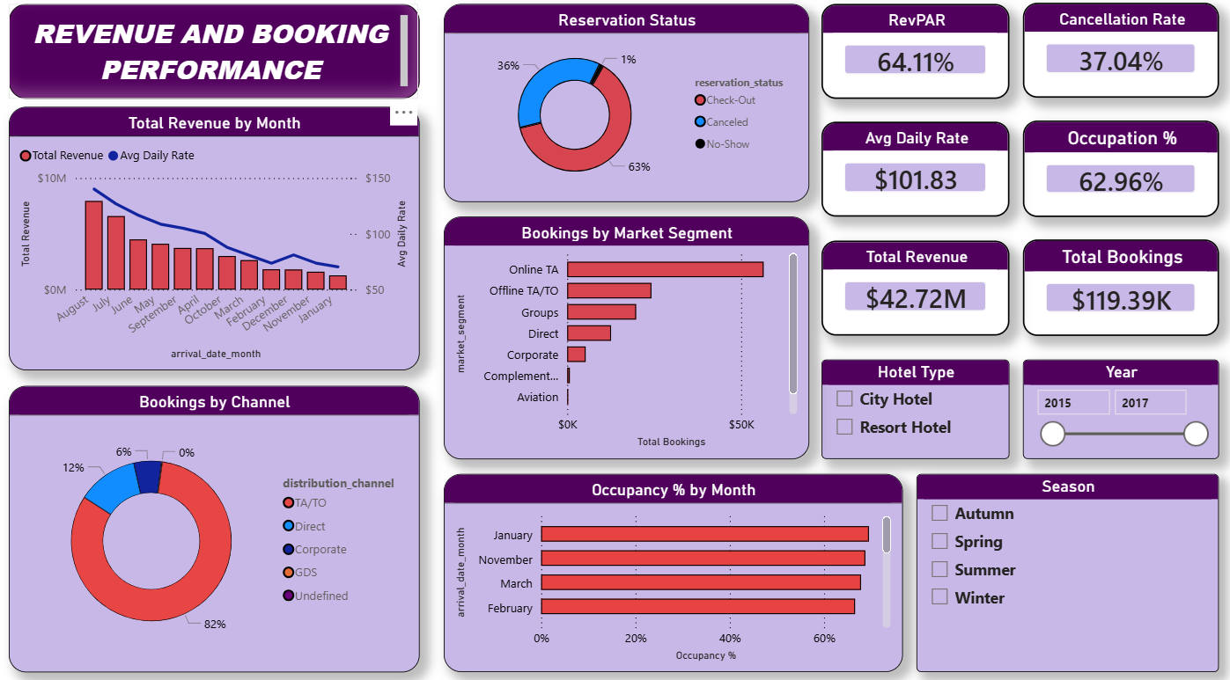This dashboard provides a top-level overview of overall hotel revenue performance, booking volumes, and distribution channel contribution. It is designed for hotel General Managers who need a quick snapshot of overall business health.
KPI Cards displayed:
- RevPAR: 64.11%
- Cancellation Rate: 37.04%
- Avg Daily Rate: $101.83
- Occupancy %: 62.96%
- Total Revenue: $42.72M
- Total Bookings: 119.39K
Visuals included:
- Total Revenue by Month (Combo Chart) — A combination bar and line chart plotting Total Revenue as bars and Average Daily Rate as a line across arrival months. This visual reveals that August and July record the highest revenue, while January and February represent the weakest months.
- Reservation Status Donut Chart — Displays the split between Check-Out (63%), Cancelled (36%), and No-Show (1%) reservations, providing an immediate view of booking outcome distribution.
- Bookings by Market Segment (Horizontal Bar Chart) — Ranks all booking channels including Online TA, Offline TA/TO, Groups, Direct, Corporate, Complementary, and Aviation by total bookings. Online TA dominates with the highest share.
- Bookings by Channel (Donut Chart) — Shows distribution channel contribution to total bookings. TA/TO accounts for 82% of all bookings, confirming OTA dominance.
- Occupancy % by Month (Horizontal Bar Chart) — Displays monthly occupancy rates, with January and November recording the highest occupancy and February showing the lowest.
Slicers: Hotel Type (City Hotel / Resort Hotel), Year (2015–2017), Season (Autumn, Spring, Summer, Winter).

Dashboard 2 — Occupancy & Revenue Analysis
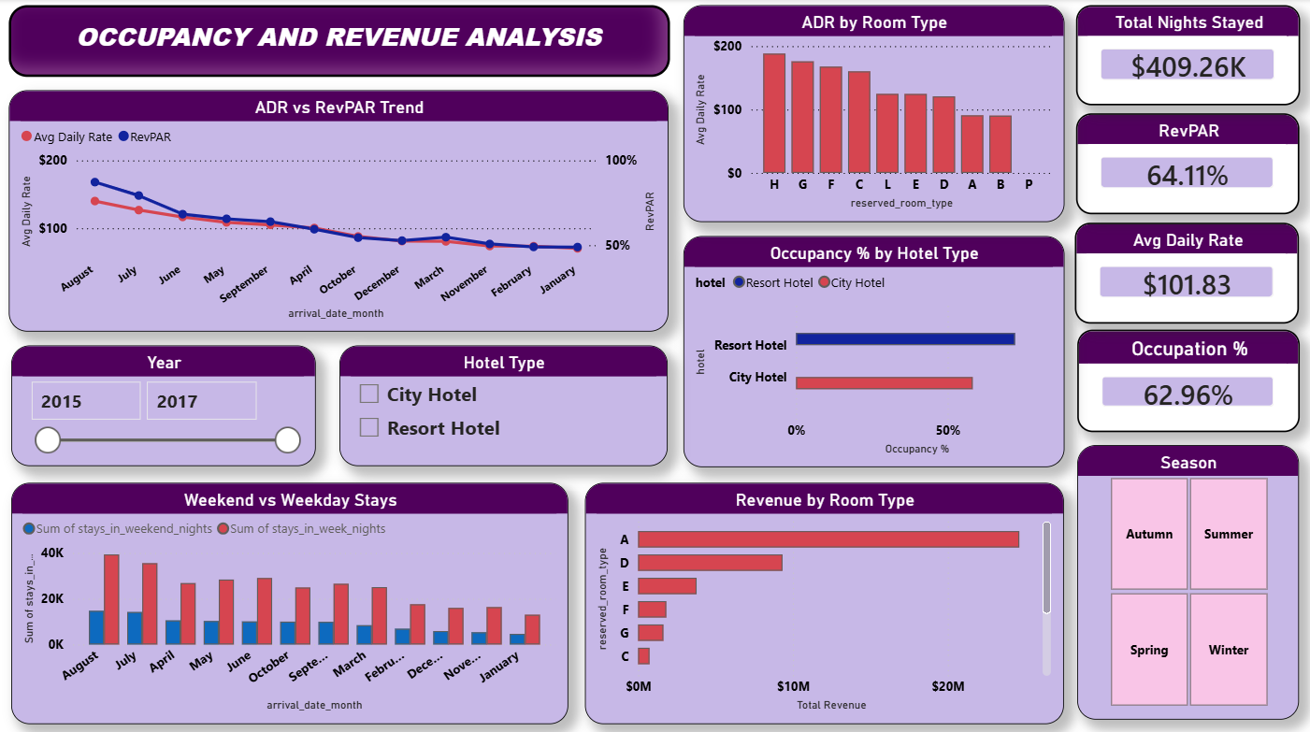This dashboard focuses on room-level revenue performance, ADR and RevPAR trends over time, and the contribution of different room types to overall occupancy and revenue. It is designed for Revenue Managers responsible for pricing and room inventory decisions.
KPI Cards displayed:
- Total Nights Stayed: $409.26K
- RevPAR: 64.11%
- Avg Daily Rate: $101.83
- Occupancy %: 62.96%
Visuals included:
- ADR vs RevPAR Trend (Line Chart) — Plots both Average Daily Rate and RevPAR as separate lines across arrival months. The visual shows that ADR peaks in summer months and drops sharply through winter, with RevPAR following a closely correlated trend.
- ADR by Room Type (Bar Chart) — Compares average daily rates across all room types (H, G, F, C, L, E, D, A, B, P). Room Type H records the highest ADR, making it the most premium room category.
- Occupancy % by Hotel Type (Horizontal Bar Chart) — Directly compares occupancy rates between City Hotel and Resort Hotel. Resort Hotels record higher occupancy during summer, while City Hotels maintain more consistent occupancy year-round.
- Weekend vs Weekday Stays (Grouped Bar Chart) — Plots weekend nights and weekday nights side by side across months. Weekday stays consistently outnumber weekend stays, reflecting the dominance of business and transient travellers.
- Revenue by Room Type (Horizontal Bar Chart) — Shows the total revenue contribution of each room type. Room Type A generates the highest total revenue due to booking volume, while Room Type H leads on ADR.
Slicers: Year (2015–2017), Hotel Type (City Hotel / Resort Hotel), Season (Autumn, Summer, Spring, Winter).

Dashboard 3 — Guest Analysis & Segmentation
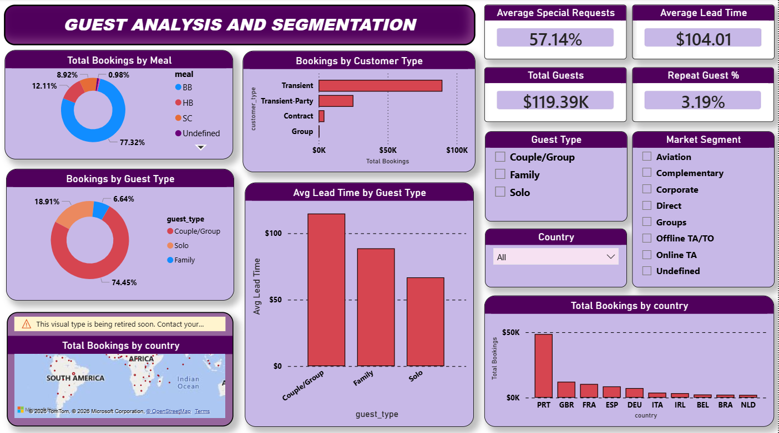This dashboard enables deep customer segmentation and geographic profiling. It helps Revenue Managers and Marketing teams understand who their guests are, where they come from, and how different guest types behave in terms of lead time and booking patterns.
KPI Cards displayed:
- Average Special Requests: 57.14%
- Average Lead Time: $104.01
- Total Guests: $119.39K
- Repeat Guest %: 3.19%
Visuals included:
- Total Bookings by Meal (Donut Chart) — Displays meal plan distribution across all bookings. Bed & Breakfast (BB) dominates at 77.32%, followed by Half Board (HB) at 12.11%, Self Catering (SC) at 8.92%, and Undefined at 0.98%. This reveals that most guests prefer the BB arrangement.
- Bookings by Customer Type (Horizontal Bar Chart) — Ranks all customer types by total bookings. Transient guests represent the largest segment with over 100K bookings, far exceeding Transient-Party, Contract, and Group segments.
- Bookings by Guest Type (Donut Chart) — Shows the split between Couple/Group (74.45%), Solo (18.91%), and Family (6.64%) guest types derived from the custom guest_type calculated column.
- Avg Lead Time by Guest Type (Bar Chart) — Compares average booking lead times across Couple/Group, Family, and Solo guest types. Couple/Group guests book the furthest in advance, while Solo guests book closest to arrival.
- Total Bookings by Country (World Map Visual) — Displays geographic distribution of bookings on an interactive map. Portugal (PRT) is the dominant source market, followed by Great Britain (GBR), France (FRA), Spain (ESP), and Germany (DEU).
- Total Bookings by Country (Bar Chart) — A supplementary bar chart ranking the top 10 source countries by booking volume, confirming Portugal as the leading market with over $50K in bookings.
Slicers: Guest Type (Couple/Group, Family, Solo), Market Segment (all segments), Country (dropdown).

Dashboard 4 — Cancellation & Forecasting Trends
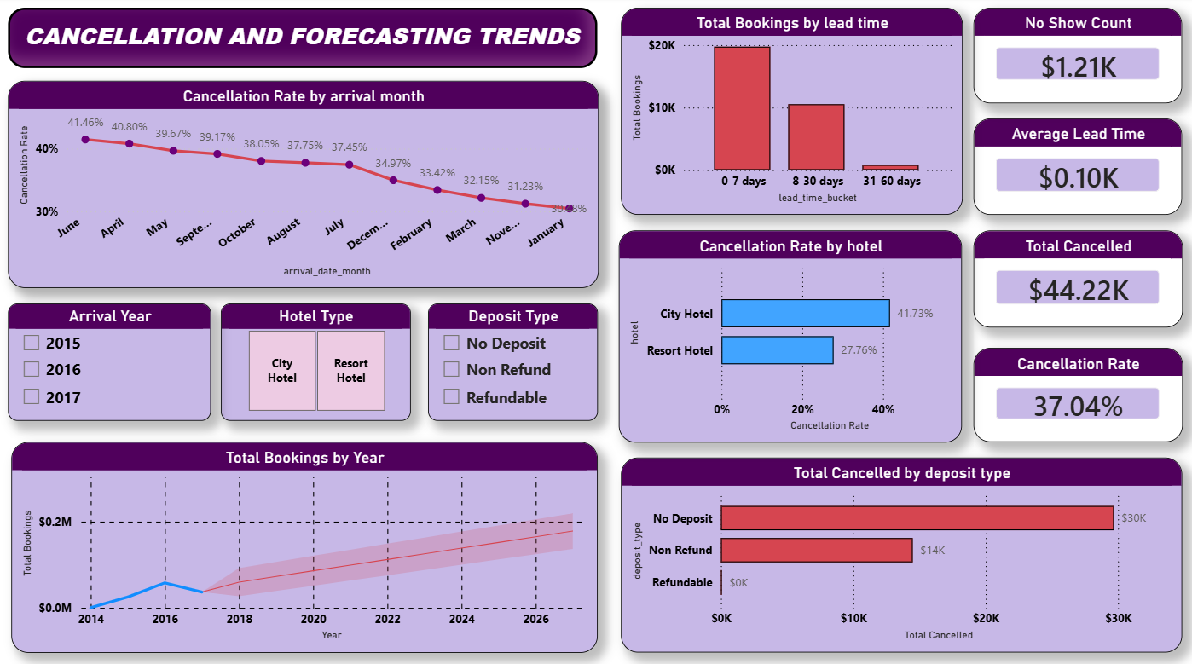This dashboard is focused on understanding cancellation behavior in depth and projecting future booking trends using a forecast line. It supports proactive risk management and revenue protection decisions for hotel operations teams.
KPI Cards displayed:
- No Show Count: $1.21K
- Average Lead Time: $0.10K
- Total Cancelled: $44.22K
- Cancellation Rate: 37.04%
Visuals included:
- Cancellation Rate by Arrival Month (Line Chart) — Plots monthly cancellation rates across all months of the year, with data labels showing exact percentages. June records the highest cancellation rate at 41.46%, while January records the lowest at 31.23%. This reveals a clear seasonal pattern in cancellation behavior.
- Total Bookings by Lead Time Bucket (Bar Chart) — Groups bookings into lead time buckets of 0–7 days, 8–30 days, and 31–60 days. Bookings made 0–7 days before arrival show significantly lower cancellation rates, confirming that last-minute bookings are more reliable.
- Cancellation Rate by Hotel Type (Horizontal Bar Chart) — Compares cancellation rates between City Hotel (41.73%) and Resort Hotel (27.76%), revealing that City Hotels carry significantly higher cancellation risk than Resort Hotels.
- Total Bookings by Year — Forecast Line (Line Chart) — Plots historical total bookings from 2014 through 2017 and extends the trend line as a forecast into future years. This visual provides a forward-looking view of booking volume trajectory.
- Total Cancelled by Deposit Type (Horizontal Bar Chart) — Breaks down total cancellations by deposit policy — No Deposit (~$30K cancellations), Non Refund (~$14K), and Refundable (~$0). This confirms that No Deposit bookings carry the highest cancellation risk by a significant margin.
Slicers: Arrival Year (2015, 2016, 2017), Hotel Type (City Hotel / Resort Hotel), Deposit Type (No Deposit, Non Refund, Refundable).

Dashboard 5 — Revenue Strategy & Pricing Insights
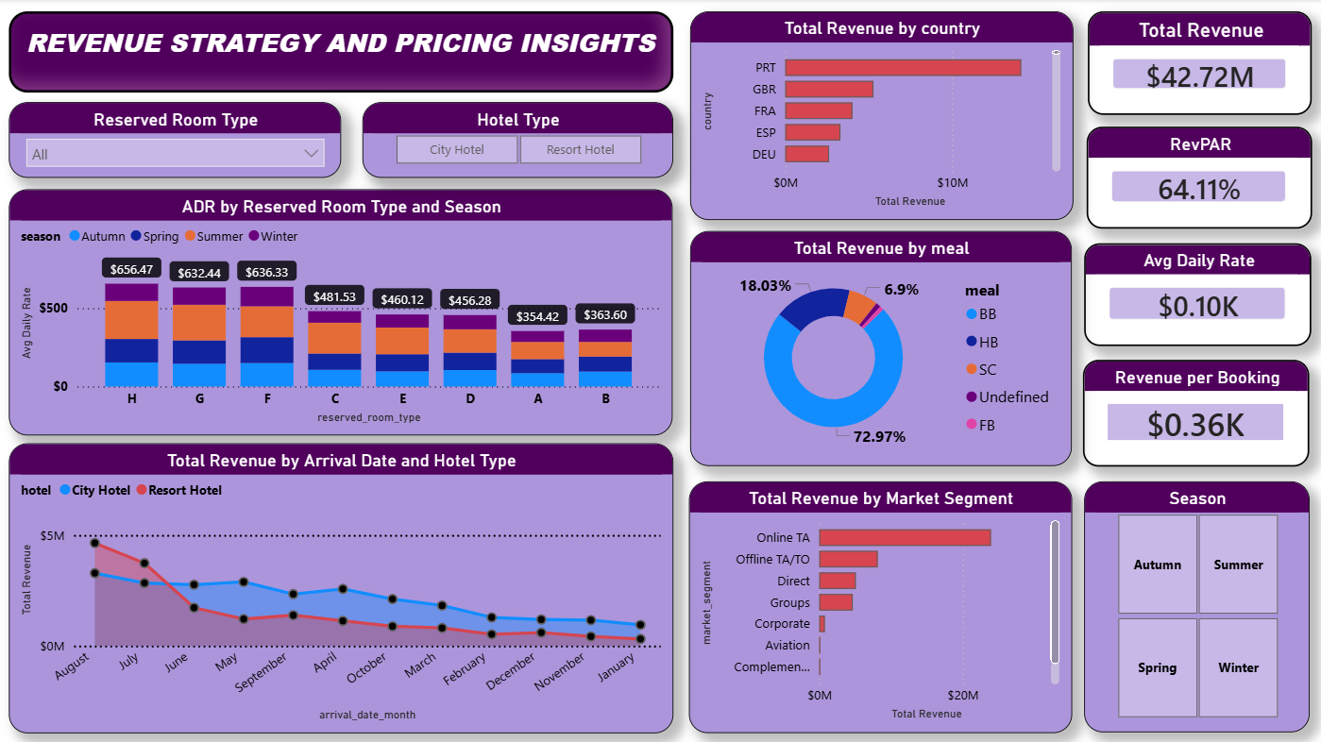This dashboard is designed to support strategic pricing and revenue optimization decisions. It consolidates room-level ADR analysis, seasonal pricing patterns, market segment revenue contribution, and country-level revenue breakdowns into a single view for senior Revenue Managers and General Managers.
KPI Cards displayed:
- Total Revenue: $42.72M
- RevPAR: 64.11%
- Avg Daily Rate: $0.10K
- Revenue per Booking: $0.36K
Visuals included:
- ADR by Reserved Room Type and Season (Stacked Bar Chart) — Displays average daily rates for each room type broken down by season (Autumn, Spring, Summer, Winter) using color-coded stacked bars. Room Type H records the highest ADR across all seasons at $656.47 in Summer, followed by Room Type G at $632.44 and Room Type F at $636.33. This visual is central to seasonal pricing strategy decisions.
- Total Revenue by Arrival Date and Hotel Type (Area Chart) — Plots total revenue over time separately for City Hotel and Resort Hotel as two distinct area layers. City Hotel consistently generates higher monthly revenue, with peak revenue months occurring in the summer period across both hotel types.
- Total Revenue by Country (Horizontal Bar Chart) — Ranks the top revenue-generating source countries. Portugal (PRT) leads significantly, followed by Great Britain (GBR), France (FRA), Spain (ESP), and Germany (DEU). This insight directly informs international marketing investment priorities.
- Total Revenue by Meal Plan (Donut Chart) — Breaks down revenue contribution by meal plan. Bed & Breakfast (BB) accounts for 72.97% of all meal plan revenue, followed by Half Board (HB) at 18.03% and Self Catering (SC) at 6.9%.
- Total Revenue by Market Segment (Horizontal Bar Chart) — Compares revenue contribution across all booking channels. Online TA is the highest-revenue market segment, followed by Offline TA/TO and Direct bookings. Aviation and Complementary segments contribute the least.
Slicers: Reserved Room Type (dropdown — All), Hotel Type (City Hotel / Resort Hotel), Season (Autumn, Summer, Spring, Winter).

10. BUSINESS IMPACT
The HotelRevAI project delivers measurable business value across five key dimensions:
1. Revenue Optimization The dashboards identified Online TA as the dominant revenue channel and revealed that Room Type H commands the highest ADR across all seasons. ADR and RevPAR trends were analyzed across months and room types, revealing clear pricing opportunities during peak summer months and seasonal underperformance in winter that can be addressed through targeted promotions.
2. Improved Occupancy and Demand Planning Booking distribution was analyzed across months, seasons, and hotel types. Lead time patterns were studied across guest types, and weekend versus weekday stay trends were evaluated — providing the foundation for accurate demand forecasting, dynamic pricing adjustments, and optimized room inventory allocation.
3. Cancellation Risk Monitoring and Revenue Protection With an overall cancellation rate of 37.04% and City Hotels reaching 41.73%, the cancellation dashboards enable management to identify the highest-risk months, hotel types, and deposit policy combinations. The finding that No Deposit bookings account for nearly $30K cancellations enables targeted policy interventions to reduce revenue leakage.
4. Customer Segmentation and Targeted Marketing Guests were segmented by market segment, customer type, guest type, and country of origin. Portugal, Great Britain, and France were identified as the top three source markets. With a Repeat Guest % of only 3.19%, there is significant opportunity for loyalty programme development targeting high-value returning guest groups.
5. Unified Data-Driven Decision Framework All 13 DAX-based KPIs and five interactive dashboards with cross-filtering slicers provide a single, scalable decision-support framework that replaces hours of manual report preparation with instant, filterable analytics — enabling consistent, evidence-based management decisions at every level of hotel operations.

11. CONCLUSION
The HotelRevAI project successfully demonstrates how data visualization and business intelligence tools can transform hotel revenue management. By processing and modeling a real-world booking dataset of 1,17,430 records, the project delivered five fully interactive dashboards that provide deep visibility into revenue performance, occupancy trends, customer segmentation, cancellation risk, and pricing strategy.
The 13 DAX-powered KPIs and Power BI visualizations equip hotel management with the tools needed to optimize pricing strategies, reduce cancellation losses, identify high-value guest segments, and respond faster to market changes. The structured analytical pipeline — from raw data through Power Query preprocessing, M Language column engineering, DAX metric modeling, and interactive dashboard visualization — establishes a reusable and scalable framework for hotel revenue management.
This project not only addresses the immediate analytical needs of hotel revenue management but also demonstrates the broader potential of Power BI as a replacement for static Excel reporting in the hospitality sector.

12. FUTURE SCOPE
While HotelRevAI delivers significant value in its current form, several enhancements can further extend its capabilities:
- Real-time data integration — Connect the Power BI model to live hotel booking systems via APIs or streaming datasets to enable up-to-the-minute dashboard updates.
- Machine learning integration — Build predictive cancellation models using Python or Azure ML to forecast cancellation probability at the individual booking level with greater precision.
- Dynamic pricing recommendations — Develop an AI-based pricing engine that suggests optimal ADR adjustments based on demand patterns, lead time, season, and market segment behavior.
- Sentiment analysis — Incorporate guest review and feedback data to correlate satisfaction scores with booking behavior, cancellation patterns, and repeat guest rates.
- Multi-property expansion — Extend the analytical framework to support analysis across multiple hotel properties with cross-property performance benchmarking.
- Automated reporting — Schedule automated dashboard report delivery to hotel stakeholders via Power BI Service subscriptions and email alerts.

13. REFERENCES
Dataset: Hotel Booking Main Dataset (hotel_booking_main.xlsx) — real-world hotel booking-level transactional data with 1,17,430 records across 32 columns spanning 2015–2017.
Tool: Microsoft Power BI Desktop — for data modeling, DAX measure development, and interactive dashboard visualization.
Tool: Power Query Editor — for data cleaning, null handling, column removal, and data type correction.
Language: M Language — for custom calculated column creation within Power Query Editor.
Language: DAX (Data Analysis Expressions) — for KPI and business metric measure development.
Methodology: KPI-driven interactive dashboard design for hospitality revenue management and business intelligence storytelling.
Mentor: Selciya — Infosys Springboard Virtual Internship 6.0, Batch 13, Group 2, Team D.

